

**WEB APPLICATION VULNERABILITY ASSESSMENT**



**Learning circle:**

**Weirdos**

Table of Contents

1. Executive Summary
2. Scan Results
3. Our Findings
4. Risk Assessment
5. Recommendations

**Executive Summary**

The purpose of this vulnerability scan is to gather data on Windows and third-party software patch levels on hosts

**Scan Results**

 The raw scan results will be provided upon delivery.

**Our Findings**

The results from the credentialed patch audit are listed below.

It is important to note that not all identified hosts were able to be scanned during this assessment – of the many hosts identified, only 40 were successfully scanned and raised as alerts.

In addition, some of the hosts that were successfully scanned were not included in the host list provided.

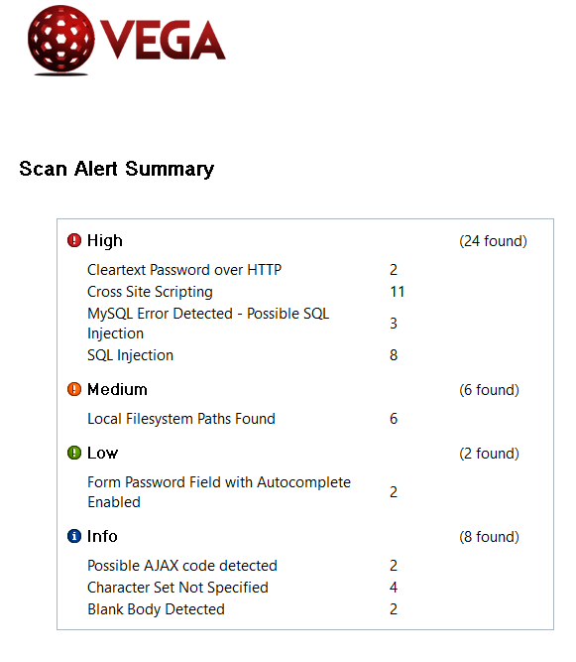

**Risk Assessment**

This report identifies security risks that could have significant impact on mission-critical applications used for day-to-day business operations.

|  |  |  |  |
| --- | --- | --- | --- |
| High | Medium | Low | Info |
| 24 | 6 | 2 | 8 |

**Some of the Screenshots of the alert scan:**

